Talk for Writing (T4W)
- What is T4W?
- T4W overview- Pie Corbett
- A quick guide to T4W

Punctuation
- Kung-Fu punctuation
- Contractions & Apostrophes
- VCOP- Punctuation

Handwriting
- Correct letter formation
- Nelson Handwriting- The first join

Typing Skills
- Dance Mat Typing
- Doorway Online- typing

These links will take you to either web pages or short videos that demonstrate the strategies and language used in Oxgang for the teaching of Literacy.
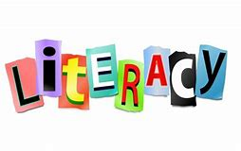
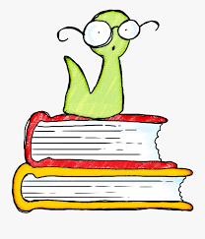

Right click on each link and select ‘open hyperlink’ to view the pages on your browser.

North Lanarkshire Spelling
- A guide for parents and carers
- Active Literacy- Stage 1
- Active Literacy- Stage 2/3
- Active Literacy- Stage 4/5

Reading Skills
- Active Literacy- Reading

Higher Order Thinking Skills
- Encouraging higher order thinking skills at home

Literacy Games
- Letters and Sounds
- Learning to Read
- Home Literacy Games
- BBC Literacy
- Punctuation Games
- Spelling and Grammar Games
- Writing Games
- Interactive Spelling
- Kids Spell

