[](http://www.bing.com/images/search?q=rights+respecting+schools+award&FORM=HDRSC2#view=detail&id=F0429AE8F12542EE14F6E79B707BCDEECDE049B0&selectedIndex=0)Oxgang Primary School

Learning Together, Achieving Together, Respecting Each Other



***Thurs 1st Mar*** *– NSPCC Speak Out Stay safe programme for P1-7*

***Tues 6th Mar*** *– P6 Edinburgh Castle Gaelic trip*

***Tues 6th Mar*** *6:30pm – PTA meeting*

***Thurs 8th Mar*** *– P5 Stirling Castle Trip*

***Fri 9th Mar*** *– P6 Fairtrade Coffee Afternoon for P6 parents*

***Mon 12th Mar*** *- 9am – P3 assembly*

***Tues 13th Mar*** *6:30pm – Parent Council/ Pupil Council joint meeting*

***Mon 19th Mar*** *– Achievement Assembly*

***Thurs 22nd Mar*** *– dress rehearsal for OGT*

***Mon 26th Mar 9:30am*** *– Church Service – all welcome*

***Tues 27th Mar –*** *Dance Marathon*

***Wed 28th Mar 6:30pm*** *– Oxgang’s Got Talent*

***Wed 28th Mar*** *– report cards issued*

***Thurs 29th Mar*** *– Term 3 Treat – Inflatables Day!*

***Thurs 29th Mar –*** *Spring break – finish 2:30pm.*

***Mon 16th April*** *– start back 9am*

***Thurs 26th April*** *– Parents’ Night*

***Mon 30th April*** *– 9am - P2 assembly*

***Tues 1st May******– Fri 4th May*** *– P7 residential trip to Ardmay*

***Mon 7th May*** *- holiday*

**Dates for your diary**

**P6 Ski trip**

At the end of January, Primary 6 participated in a residential trip at Nethybridge.   
The children developed their skiing skills on the dry slopes and then put these into practice on the snow. They also took part in a range of outdoor activities. They experienced the zip wire, used an adventure course and took part in team problem solving challenges. They also had a chance to go up the Cairngorms on the Funicular railway.  
The centre in Nethybridge also had a swimming pool, games room and basketball court which meant there was lots to keep the children busy every night after their return from the slopes. The staff were delighted with the effort put in by everyone throughout the week.   
Primary 6 returned to school at the end of their week tired but happy!

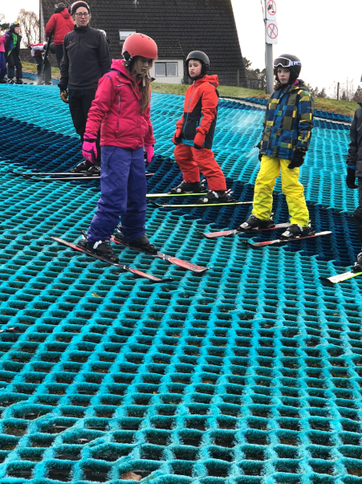

**Oxgang’s 50th Birthday!**

We are starting to plan for Oxgang’s 50th birthday celebrations in Sept 2018.  
Can you help? Do you have any photos from Oxgang from previous years that we could take copies of? Do you have any memories you would like to share? Please ask any friends or family that may have been at Oxgang over the past 5 decades if they have anything that they could share? Thank you.

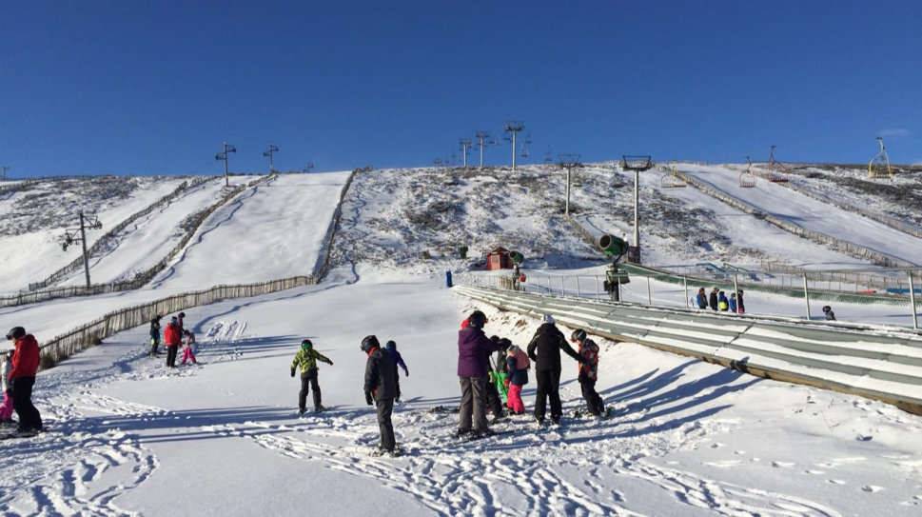



**All Day Dance Challenge – Tues 27th March**  
We are trying to raise money, through a sponsored event, to enhance our ICT   
provision by purchasing additional ipads. This will build on the ipads already   
purchased through school fund and PTA funding.  
The Pupil Council gathered the views of their peers and then took a vote on the   
ideas put forward. They have decided to have a sponsored All Day Dance Challenge where at least two classes are dancing at all times throughout the day. This will take place on Tues 27th March. A sponsor form will be sent home next week.



**Bake Sale**  
Thank you to everyone   
who supported the bake   
sale. We had a tremendous   
response and had an extremely difficult job selecting winners and runners up.

Through the sale of the cakes the Pupil Council raised £300. This money has been sent to Guide Dogs for the Blind, a charity the children were keen to support.

**Family Learning**We have a family learning worker assisting in Oxgang on 2 days each week. She has been meeting with some parents and helping with ideas for supporting children at home to improve their learning.

If you would like assistance from our family learning worker with any aspect of learning at home please contact the school office on 01419552313 and ask for Mrs Adams who will arrange this.



**Online Safety Parent Workshop**  
**An information session is being run in Oxgang by the NSPCC for parents on Thurs 1st March 2:20-2:50** to help support parents with keeping children safe online.

Please come along to hear these important messages and help keep your child safe while using the internet.

**Rights Respecting Schools – Fair Trade**  
Fairtrade Fortnight runs from 26th Feb – 11th Mar. Next week we have an assembly focussed on Fairtrade with the whole school. P6 are studying a topic on Fairtrade this term and are planning   
a Fairtrade coffee afternoon for their   
family and friends – more details will   
follow from P6.





**Oxgang’s Got Talent**  
Auditions and rehearsals for OGT are well underway. We are looking forward to seeing our talented pupils on stage on Wed 28th March. Ticket information will be issued shortly.

**Twitter**  
We now have over 300 followers on our school Twitter and we post updates daily about what is going on in classes and for the whole school. If you haven’t yet signed up please join us @OxgangPs.  
Grandparents and other family members   
can also sign up to see what is going on in   
Oxgang.