Language Links and Games

Online games for all languages –
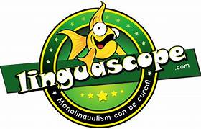
Linguascope.com
(Ask your teacher for username and password)
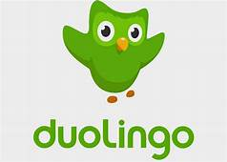
Duolingo.com

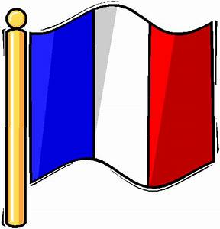  French | Numbers  https://www.youtube.com/watch?v=lsc3qLMaCu8 https://www.youtube.com/watch?v=DnrTrbJ6mYs  Days of the week  https://www.youtube.com/watch?v=Lpwf5N0rfVE  Months of the year  https://www.youtube.com/watch?v=7_u2SigckNQ  The alphabet  https://www.youtube.com/watch?v=YkFXGlHCn_o  Colours  https://www.youtube.com/watch?v=kzR_d6uJkb8  Food  https://www.youtube.com/watch?v=nJ03KjwiIVM
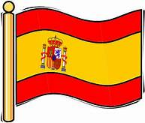  Spanish | Numbers  https://www.youtube.com/watch?v=8ydJr1Is8xI https://www.youtube.com/watch?v=6FEyfy5N3Nc  Days of the week  https://www.youtube.com/watch?v=C4fREj60Crk  Months of the year  https://www.youtube.com/watch?v=IKznbHvPFwc  The alphabet  https://www.youtube.com/watch?v=5MJbHmgaeDM  Colours  https://www.youtube.com/watch?v=zpLQSdu4V94
Gaelic | Introductions  https://go-gaelic.scot/topics/01-introductions/  Numbers  https://go-gaelic.scot/topics/03-numbers/  Days of the week  https://go-gaelic.scot/topics/04-days-week/  Colours  https://go-gaelic.scot/topics/06-colours/  Weather  https://go-gaelic.scot/topics/05-weather/

